**Phrasal Verbs - Computers and Technology**

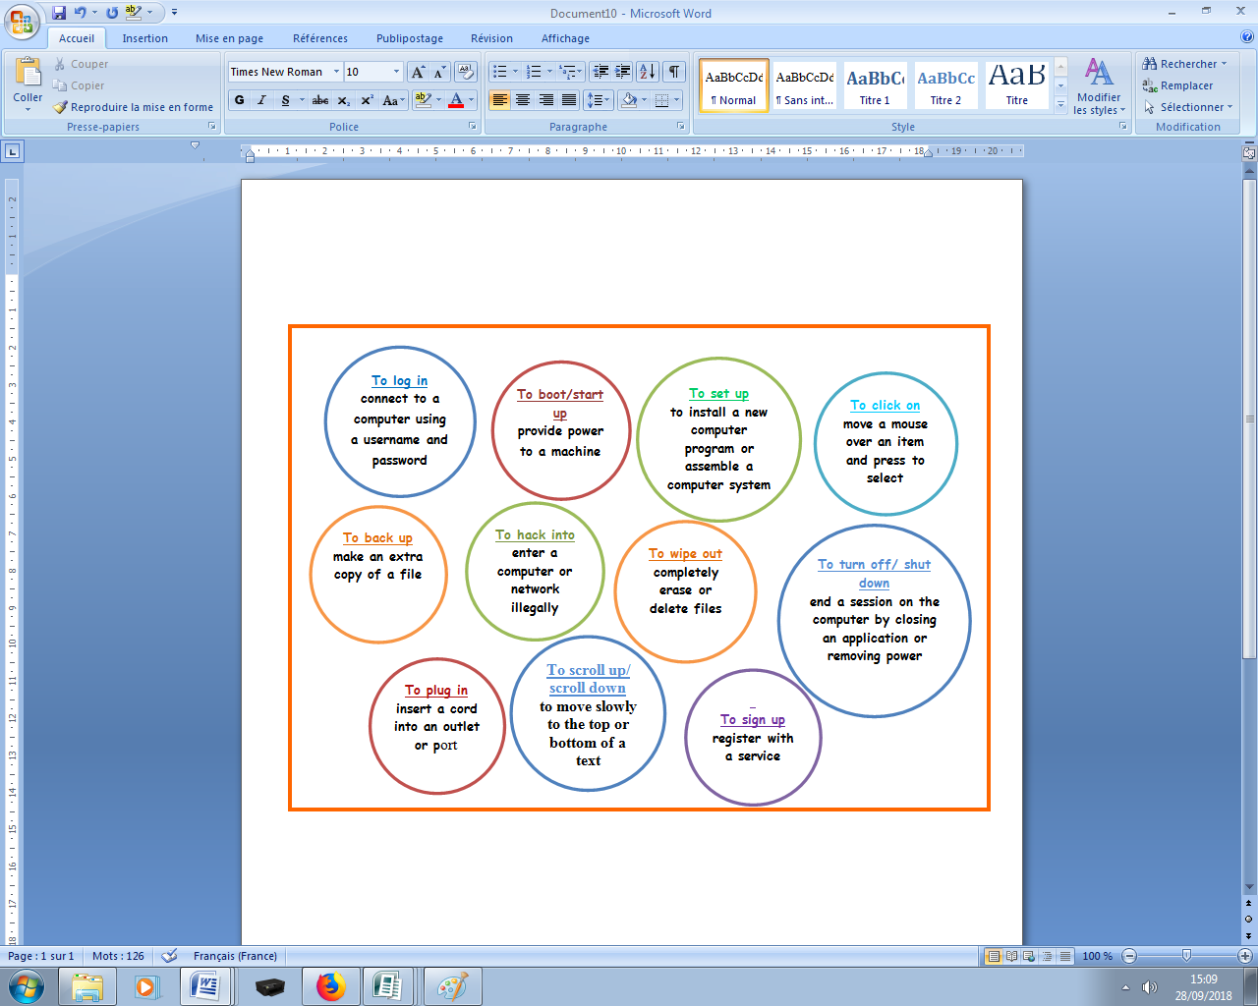

**Complete the sentences with the missing words.**

***log in wipe out went down signed up***

***scroll down back up hacked into shut down***

I’m tired, so I’m going to **___shut down_____** the computer for today.

Be sure you _**wipe out**____ your files before you change systems.

Someone ___**hacked into**________ my bank account and stole millions of dollars.

Before you donate your computer, be sure you __**back up**__ the hard drive.

Recently, Paula __**signed up**__ for an online dating service.

The news story was so long I had to __**scroll down**__________ a lot to read it all.

I cannot send any emails because the server __**went down**__.

I forgot my password, so I couldn't ____**log ing**___ to my computer

**Read the following conversation and fill in the gaps with the appropriate phrasal verb.**

***hack into hurry up log onto popped up put in log into Click on plug in get into turned on***

**Customer Service:** Computer help desk. How can I help you ?  
**Customer:** I need your help. I can’t ___**log into**_______ the system.  
**Customer Service:** I can help you with that. You need to ___**plug in**___ your computer and power it up.  
**Customer:** I’ve already done all that.  
**Customer Service:** So you’ve _____**turned**______ it _____**on**______ ?  
**Customer:** Yes, it’s on. I need to the _**log onto_____**network.  
**Customer Service:** You want to ___**get into**___ the system.  
**Customer:** Yes. but I can’t.  
**Customer Service:** Then I need you user ID, please.  
**Customer:** It’s 46821. Please __**hurry up**___ because I’ve got a conference call starting in five minutes.  
**Customer Service:** OK, no problem. I just sent you a link.  
**Customer Service:** __**Click on**_____ the link and then scroll down.  
**Customer:** Ah. A message just ____**popped up**_____.  
**Customer Service:** What does it say?  
**Customer:** ‘Are you a robot?’ It wants me to type two words in a little box.  
**Customer Service:** Oh. Are you a robot?  
**Customer:** No, of course not!  
**Customer Service:** Sometimes robots try to__**hack into**___ our system.  
**Customer:** I’m a human being!  
**Customer Service:** Then just _**put in**_______ the words. Key them in.  
**Customer:** It’s impossible. I can’t read them.  
**Customer Service:** Sorry then. I can’t help you.